

Lab 01C: Spirograph

# Course Learning Outcomes:

CLO 1 Describe the fundamental structures of an agent-based programming language

CLO 2 Solve a problem by using an agent-based programming language

CLO 3 Compose logical structures (algorithms) to produce an adequate solution for a problem

# Module Learning Objectives:

Install the NetLogo program, or access NetLogo online by creating programs with it. (CO 2)

Creating a comment header. (CO 3)

Practice using basic commands in NetLogo (CO 1)

Create a sense of classroom community

# ASSIGNMENT:

Use NetLogo Turtle Graphics to draw a unique rosette (Spirograph) pattern. This is done by using two turtle commands: forward and right, in a procedure called by a NetLogo “go” button with the “forever” box checked.

In the screen captures below, there are circular arrows in the lower right corner of the “go” button. These arrows indicate that the forever box in the “go” button’s properties has been checked. The “setup” button calls a procedure that clears NetLogo’s model view plane, creates one turtle, and sets the turtle’s heading, pen size and color. The “go” procedure instructs the turtle to move forward and turn. The student should experiment with different distances and angles for the turtle to move forward and turn. Also, note that more interesting spirographs can be created if the turtle moves and turns more than once and by different amounts in the go procedure.

The figure on the left was created by clicking “setup” then clicking the go button; since the “go” button has the forever option checked it will run until it is manually stopped. The student can manually stop the “go” button by clicking on it while it is running. While the program was paused, the **hardcoded** values of color, pen size, forward distance and turn angle were changed in the code. Then the “go” button was clicked a third time to start it again. This was done for each of the 5 separate patterns.

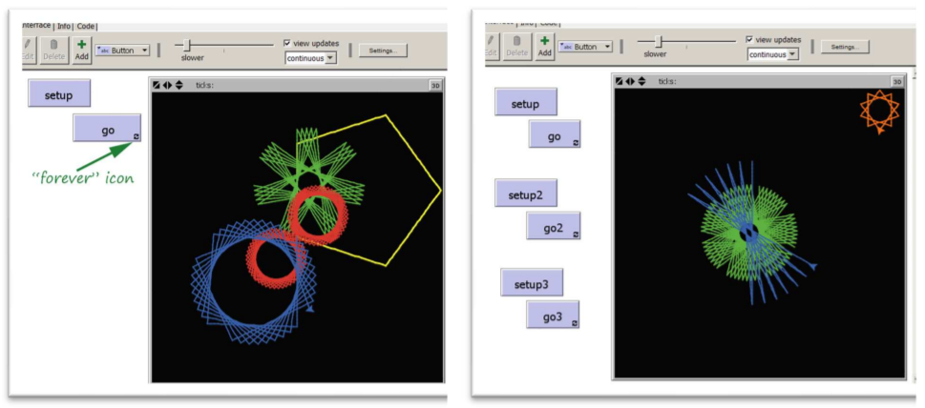

The program captured on the right above shows a different way of creating a

compound set of patterns. The second setup button, “setup2”, does NOT clear the

view plane. The “setup2” button lifts the pen, moves the turtle, then puts the pen

down again. The “go” button draws the green pattern, the “go2” button draws the

blue pattern and the go3 button draws the orange pattern.

Note: The program only needs to create **one** rosette.

# Grading Rubric [100 points total]:

[A: 2 points]: Submit the Netlogo source file:

1. Name the program: lab1C_spirograph.nlogo and submit the file to Brightspace

B: 13 points]: Submit the Netlogo source file:

2. Include a header at the top of the code. Refer to the following example:

; Author: **[Student first and last name]**

; Due Date: **[the due date]**

; Title: Lab01B: Draw a Square

; School: Central New Mexico Community College

; Course Number: CSCI 1108, Section 101

; Course Title: CS for All: Introduction to Computer Modeling

; Semester: Summer 2020

; Instructor: Sherlock Holmes

[C: 15 points]: In additional to the above comments (the header), include in-line comments. In other words, include comments that summarize the purpose or result of running a procedure, or use comments to describe particular lines of code.

[D: 15 points]: IMPORTANT: Include a detailed Info tab. See the document *Coding Standards Guidelines* for more information. Don’t forget.

[E: 25 points]: Make sure the “Setup” button clears the world and creates a turtle, and the “go” button instructs the turtle to draw a rosette.

[F: 30 points]: The program’s rosette should be creative and interesting. No squares!

[G: 5 extra points]: Draw a nested Spirograph image. By “nested” I mean that one figure is centered inside the other.

[H: 5 extra points]: After part G has been finished, modify the program so that it draws 5 copies of the nested pattern in different locations.